**Neha Malhotra**  **R.L. Institute M: 9416974837**

**Subject: Biology**

**Topic: Biomolecules**

**M.M. 300 COMPETITIVE TEST**  **Time: 60 Min.**

1. All the macromolecules are results of the process of polymerization, a process in which repeating subunits termed monomers are bound into chains of different length. All macromolecules are polymers , except:

|  |  |  |  |
| --- | --- | --- | --- |
| a) Nucleic acids | b) carbohydrates | c) lipids | d) Proteins |

1. Which of the following are basic amino acids?

|  |  |  |  |
| --- | --- | --- | --- |
| a) Glycine and alanine | b) lysine and aspartic acid | c) Glutamic acid | d) Histidine and Proline |

1. On losing the carboxyl group as carbon dioxide amino acids from biologically active :

|  |  |  |  |
| --- | --- | --- | --- |
| a) Glucose | b) Amines (histamine) | c) Alcohol | d) Nitrogenous base |

1. $β$-plated structure of proteins is present in silk fibres, the protein of these fibres is :

|  |  |  |  |
| --- | --- | --- | --- |
| a) Fibroin | b) Collagen | c) Rayon | d) Keratin |

1. Most of the blood proteins in our body is :

|  |  |  |  |
| --- | --- | --- | --- |
| a) Basic | b) Acidic | c) Neutral | d) None of these |

1. Lactose has two monosaccharides units :

|  |  |  |  |
| --- | --- | --- | --- |
| a) Glucose & maltose | b) Glucose & galactose | c) Glucose & sucrose | d) Fructose & galactose |

1. A monosaccharide is a simple polyhydroxy aldehyde or ketone molecules which cannot be further hydrolyzed into smaller units. The number of carbon atoms in monosaccharides vary from:

|  |  |  |  |
| --- | --- | --- | --- |
| a) 2 – 8 carbons | b) 2 – 7 carbons | c) 3 – 6 carbons | d) 3 – 7 carbons |

1. The sweetest of all naturally occurring sugars is :

|  |  |  |  |
| --- | --- | --- | --- |
| a) Glucose | b) Fructose | c) mannose | d) Galactose |

1. Which of the following is not a reducing sugar?

|  |  |  |  |
| --- | --- | --- | --- |
| a) Glucose | b) lactose | c) maltose | d) sucrose |

1. Which of the following will yield only glucose on hydrolysis?

|  |  |  |  |
| --- | --- | --- | --- |
| a) Sucrose | b) lactose | c) Maltose | d) Raffinose |

1. The most abundant organic compound in biosphere is :

|  |  |  |  |
| --- | --- | --- | --- |
| a) lignin | b) Cellulose | c) Pectin | d) Hemicellulose |

1. The largest amount (90 %) of cellulose amongst the natural materials is present in :

|  |  |  |  |
| --- | --- | --- | --- |
| a) Wood | b) cotton fibres | c) Rayon | d) Roughage |

1. Glycosidic linkage at place of branching in maltose has :

|  |  |  |  |
| --- | --- | --- | --- |
| a) $α$-1,4 linkage | b) $α$-1,6 linkage | c) $β$-1,4 linkage | d) $β$-1,6 linkage |

1. Monomer of chitin is :

|  |  |  |  |
| --- | --- | --- | --- |
| a) N-acetyl glucosamine | b) Mannitol | c) Glucuronic acid | d) Ascorbic acid |

1. Cellulose is :

|  |  |
| --- | --- |
| a) Heptopolysaccharide | b) Heteropolysaccharide , branched |
| c) Hexose polysaccharide | d) Pentosan polysaccharide , branched |

1. Chitin is the second most abundant organic substance in the biosphere and is present in the exoskeleton of insects and crustaceans. It is a :

|  |  |
| --- | --- |
| a) Protein | b) polysaccharide and unit is N-acetyl glucosamine |
| c) Protein and CaCO3 deposits over it | d) Lipid |

1. Which of the following is essential fatty acid with 2 double bonds in chain?

|  |  |  |  |
| --- | --- | --- | --- |
| a) Linoleic | b) Linolenic | c) Arachidonic | d) Stearic |

1. Lecithin is :
2. Fatty acid
3. Phospholipid with chlorine attached to phosphate group.
4. Cholesterol
5. Fat
6. The backbone of a nucleic acid strand is made up of :

|  |  |  |  |
| --- | --- | --- | --- |
| a) Base & phosphate | b) Sugar & phosphate | c) Sugar & base | d) Sugar, Base & phosphate |

1. Which of the following is not present in DNA?

|  |  |  |  |
| --- | --- | --- | --- |
| a) Cytosine | b) Adenine | c) Guanine | d) Thiamine |

1. Nucleotides take part in :
2. Information transfer system
3. Energy transfer system
4. Formation of NAD and FAD which act as co-enzyme of oxidizing enzymes.
5. All of these
6. A nucleotide is made up of :

|  |  |
| --- | --- |
| a) Sugar and phosphate only | b) Nitrogenous base and sugar only |
| c) Nitrogenous base , sugar and phosphate | d) Phosphate and nitrogenous base |

1. Nucleoside on hydrolysis will not yield.

|  |  |
| --- | --- |
| a) Sugar | b) Phosphoric acid |
| c) Nitrogenous base | d) Sugar and nitrogenous base |

1. Which of the following figure represents basic amino acid:

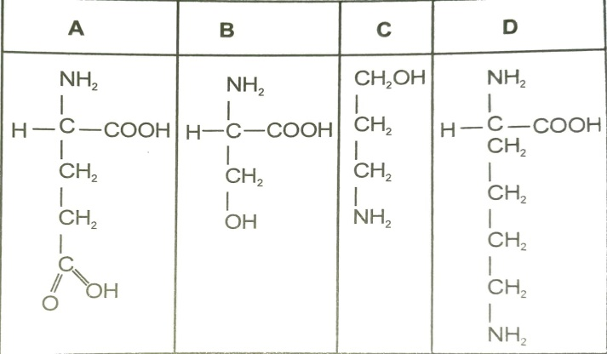

|  |  |  |  |
| --- | --- | --- | --- |
| a) A | b) B | c) C | d) D |

1. Given below is a diagrammatic representation of one of the categories of small molecular weight organic compounds in the living tissues. Identify the **category** shown and the one blank **component** ‘X’.

|  |
| --- |
|  |

|  |  |  |
| --- | --- | --- |
|  | Category | Components |
| (a) | Nucleotide | Adenine |
| (b) | Nucleoside | Uracil |
| (c) | Cholesterol | Guanin |
| (d) | Amino acid | NH2 |

1. Which of the most abundant protein in the animal world?

|  |  |  |  |
| --- | --- | --- | --- |
| a) Collagen | b) Insulin | c) Trypsin | d) Haemoglobin |

1. Which one of the following biomolecules is correctly characterized?
2. Lecithin – A phosphorylated glyceride found in cell membrane.
3. Palmitic acid – An unsaturated fatty acid with 18 carbon atoms.
4. Adenylic acid – Adenosine with a glucose phosphate molecule.
5. Alanine amino acid – Contains an amino group and an acidic group anywhere in the molecule.
6. The essential chemical components of many coenzymes are :

|  |  |  |  |
| --- | --- | --- | --- |
| a) Nucleic acid | b) carbohydrates | c) Vitamins | d) proteins |

1. In sea urchin DNA, which is double stranded, 17 % of the bases were shown to be cytosine. The percentage of the three bases expected to be present in DNA are :

|  |  |  |  |
| --- | --- | --- | --- |
|  | G (%) | A (%) | T (%) |
| (a) | 17 % | 16.5 % | 32.5 % |
| (b) | 17 % | 33 % | 33 % |
| (c) | 8.5 % | 50 % | 24.5 % |
| (d) | 34 % | 24.5 % | 24.5 % |

1. Which of the following biomolecules does have a phosphodiester bond?

|  |  |
| --- | --- |
| a) Nucleic acids in a nucleotide | b) Fatty acid in a diglyceride |
| c) Monosaccharides in a polysaccharide | d) Amino acids in a polypeptide |

1. A typical fat molecule is made up of :

|  |  |
| --- | --- |
| a) 3 glycerol and 3 fatty acids molecules | b) 3 glycerol molecules and 1 fatty acids molecules |
| c) 1 glycerol and 3 fatty acids molecules | d) 1 glycerol and 1 fatty acid molecules |

1. Which one of the following statements is wrong?

|  |  |
| --- | --- |
| a) Glycine is a sulphur containing amino acid | b) sucrose is a disaccharide |
| c) Cellulose is a polysaccharide | d) uracil is a pyrimidine |

1. Which of the following is not likely to be involved in stabilizing the three-dimensional folding of proteins?

|  |  |  |  |
| --- | --- | --- | --- |
| a) Hydrogen bonds | b) Electrostatic interaction | c) Hydrophobic interaction | d) Ester bonds |

1. Sugar and Amino acid are :

|  |  |  |  |
| --- | --- | --- | --- |
| a) primary metabolites | b) secondary metabolites | c) Feed stock | d) Inoculum |

1. Middle lamella mainly contain :

|  |  |  |  |
| --- | --- | --- | --- |
| a) Ca | b) Cu | c) K | d) Na |

1. What is a disaccharide?

|  |  |  |  |
| --- | --- | --- | --- |
| a) Galactose | b) Fructose | c) Maltose | d) Dextrin |

1. To get quick energy one should use:

|  |  |  |  |
| --- | --- | --- | --- |
| a) Carbohydrates | b) Fats | c) Vitamins | d) Proteins |

1. Which is not a polysaccharide?

|  |  |  |  |
| --- | --- | --- | --- |
| a) Sucrose | b) Starch | c) Glycogen | d) cellulose |

1. The simplest sugar are also called as :

|  |  |  |  |
| --- | --- | --- | --- |
| a) Disaccharides | b) Monosaccharides | c) Polysaccharides | d) Oligosaccharides |

1. Carbohydrates, the most abundant biomolecules on earth are produced by :

|  |  |
| --- | --- |
| a) Some bacteria , algae and green plants | b) All bacteria , fungi and algae |
| c) Fungi , algae and green plants | d) Viruses , fungi and bacterial cells |

1. The structure of glucose and galactose are same except with regard to :

|  |  |  |  |
| --- | --- | --- | --- |
| a) 1st carbon atom | b) 2nd carbon atom | c) 3rd carbon atom | d) 4th carbon atom |

1. The glycosidic bond seen in lactose is :

|  |  |  |  |
| --- | --- | --- | --- |
| a) $α$-1,4 linkage | b) $β$-1,4 linkage | c) $α$-1,6 linkage | d) $α$-1,2 linkage |

1. Sucrose is made up of glucose and fructose, which are reducing sugars, but sucrose is a non-reducing sugar, Because the linkage involves :

|  |  |
| --- | --- |
| a) 1st carbon of glucose and 2nd carbon of fructose | b) 2nd carbon of glucose and 1st carbon of fructose |
| c) 1st carbon of glucose and 4th carbon of fructose | d) 4th carbon of glucose and 1st carbon of fructose |

1. Raffinose is a :

|  |  |  |  |
| --- | --- | --- | --- |
| a) Trisaccharide | b) Disaccharide | c) Polysaccharide | d) Monosaccharide |

1. Which of the following is the characteristics of plants?

|  |  |  |  |
| --- | --- | --- | --- |
| a) Glucose & cellulose | b) Pyruvic acid | c) Cellulose & starch | d) Starch & pyruvic acid |

1. Starch is made up of :

|  |  |  |  |
| --- | --- | --- | --- |
| a) Fructose | b) Cellobiose | c) Amylopectin | d) Amino acids |

1. An example of hexose sugar is :

|  |  |  |  |
| --- | --- | --- | --- |
| a) Mannose | b) Galactose | c) Arabinose | d) Both (a) and (b) |

1. An example of ketose sugar is :

|  |  |  |  |
| --- | --- | --- | --- |
| a) Ribose | b) Xylose | c) Erythrose | d) Fructose |

1. The glycosidic bond seen in sucrose is :

|  |  |  |  |
| --- | --- | --- | --- |
| a) $α$-1,4 linkage | b) $β$-1,4 linkage | c) $α$-1,6 linkage | d) $α$-1, $β$-2 linkage |

1. The difference in D and L forms of sugars are based on :
2. Spatial arrangement of carbon atom to which the functional group is attached .
3. Configuration of H and OH groups around the penultimate shell.
4. If the plane of polarized light is rotated to left (levo), it is L form and if shifted to right (dextro), it is D form.
5. Spatial arrangement of H and OH group at the last carbon atom.
6. Glucose and galactose are :

|  |  |
| --- | --- |
| a) Are anomers | b) Are constituents of sucrose |
| c) Differ in configuration around the 2nd carbon atom | d) Are epimers |

1. Inulin is a :

|  |  |  |  |
| --- | --- | --- | --- |
| a) lipid | b) Protein | c) polysaccharide | d) Human insulin |

1. The most abundant structural polysaccharide is cellulose. And the second largest structural polysaccharide is :

|  |  |  |  |
| --- | --- | --- | --- |
| a) Chitin | b) Mannan | c) Glycogen | d) Gyaluronic acid |

1. Glycogen is stored in :

|  |  |  |  |
| --- | --- | --- | --- |
| a) Liver and muscles | b) Liver only | c) Muscles only | d) pancreas |

1. Which of the following is essential fatty acids?

|  |  |  |  |
| --- | --- | --- | --- |
| a) Linoleic acid | b) linolenic acid | c) Arachidonic acid | d) all of these |

1. Phospholipids are __________ in nature.

|  |  |  |  |
| --- | --- | --- | --- |
| a) Hydrophilic | b) Amphibolic | c) Hydrophobic | d) Amphipathic |

1. Phospholipid are important cell membrane constituents because :

|  |  |
| --- | --- |
| a) contain glycerol | b) can form bilayers in water |
| c) Combine covalently with protein | d) Contain polar and non-polar portions |

1. Unsaturated fatty acids have :

|  |  |  |  |
| --- | --- | --- | --- |
| a) Palmitic acid | b) Oleic acid | c) 1 or more double bond | d) both (b) and (c) |

1. Cholesterol is a crucial molecule in animals as :
2. It is necessary for survival.
3. It is the energy source.
4. It is helpful in hydrolysis of glycogen.
5. It is a source of many vertebrate hormones and other steroids.
6. Which part of a neuron is covered by a lipid rich layer?

|  |  |  |  |
| --- | --- | --- | --- |
| a) Dendrite | b) Cyton | c) Axon | d) Node of Ranvier |

1. Cerebrosides are :

|  |  |  |  |
| --- | --- | --- | --- |
| a) Simple lipids | b) Lipids with glucose | c) Lipids with phosphate | d) steroids |

1. Protein which is most abundant in human body is :

|  |  |  |  |
| --- | --- | --- | --- |
| a) Collagen | b) Myosin | c) actin | d) Albumin |

1. Milk protein is :

|  |  |  |  |
| --- | --- | --- | --- |
| a) Lactogen | b) Myosin | c) Casein | d) Pepsin |

1. Most simple amino acid is :

|  |  |  |  |
| --- | --- | --- | --- |
| a) Tyrosine | b) Lysine | c) Glycine | d) Aspartic acid |

1. Which of the following is basic amino acid?

|  |  |  |  |
| --- | --- | --- | --- |
| a) Leucine | b) Lysine | c) methionine | d) Aspartic acid |

1. The primary structure of protein is made up of :

|  |  |  |  |
| --- | --- | --- | --- |
| a) Hydrogen bond | b) Ionic bond | c) Peptide bond | d) None of these |

1. The base pairs of DNA are correctly shown as :

|  |  |  |  |
| --- | --- | --- | --- |
| a) A $≡$ T and C $=$ G | b) A $=$ T and C $=$ G | c) A $≡$ T and C $≡$ G | d) A $≡$ T and C $≡$ G |

1. The length of one full turn of DNA is :

|  |  |  |  |
| --- | --- | --- | --- |
| a) 3.4 $Å$ | b) 34 $Å$ | c) 20 $Å$ | d) 2 $Å$ |

1. The acidic character of DNA and RNA is due to :

|  |  |  |  |
| --- | --- | --- | --- |
| a) Purine | b) Pyrimidine | c) Phosphate group | d) none of these |

1. According to Watson and Crick , how many base pairs are there in each turn of the helix of DNA?

|  |  |  |  |
| --- | --- | --- | --- |
| a) 10 | b) 11 | c) 12 | d) 13 |

1. Two rings are there in :

|  |  |  |  |
| --- | --- | --- | --- |
| a) Guanine | b) Thymidine | c) Uracil | d) Cytosine |

1. In an experiment it was found that adenine constituents 31 % and guanine 19 %. The quantity of cytosine in this DNA is likely to be :

|  |  |  |  |
| --- | --- | --- | --- |
| a) 19 % | b) 40 % | c) 31 % | d) 50 % |

1. The rule that in a DNA the amount of adenine equals to that of the thymine and that of guanine equals to that of cytosine is known as :

|  |  |  |  |
| --- | --- | --- | --- |
| a) Allen’s rule | b) Jordan’s rule | c) Chargaff’s rule | d) Stahl’s rule |

1. The below structure formula belongs to :

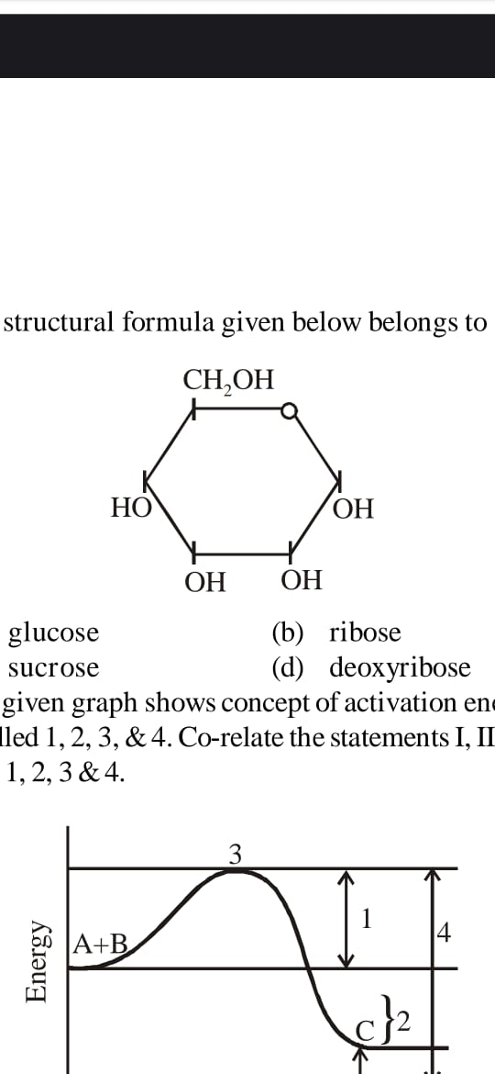

|  |  |  |  |
| --- | --- | --- | --- |
| a) Glucose | b) Ribose | c) Sucrose | d) Deoxyribose |

1. Which of the two groups of following formula involved in peptide bond between different amino acids?

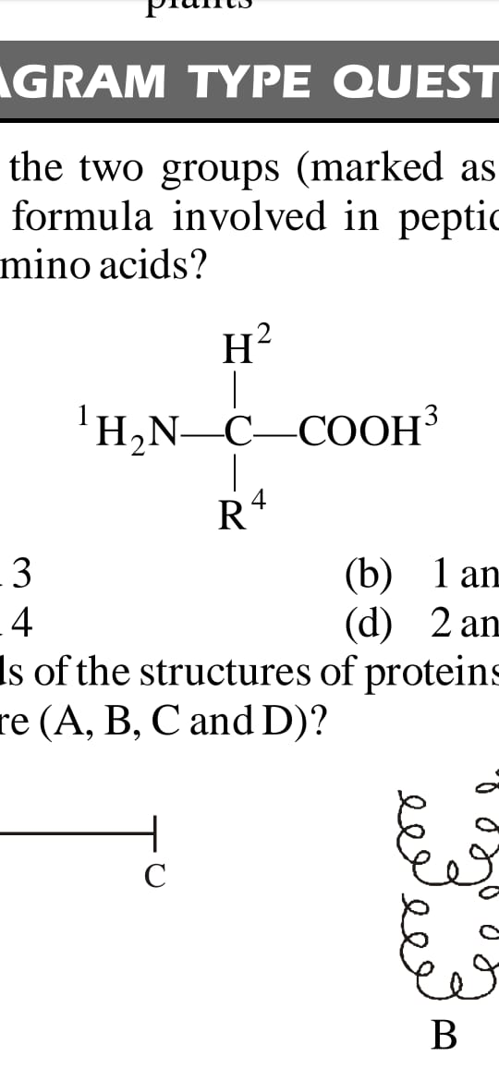

|  |  |  |  |
| --- | --- | --- | --- |
| a) 2 & 3 | b) 1 & 3 | c) 1 & 4 | d) 2 & 4 |

1. n
2. Members of phylum porifera commonly called as :

|  |  |  |  |
| --- | --- | --- | --- |
| a) | b) | c) | d) |

1. Majority of poriferans are inhabitant of :

|  |  |  |  |
| --- | --- | --- | --- |
| a) Fresh water | b) Brackish water | c) Marine water | d) None of above |

1. Sponges have canal system for circulation of :

|  |  |  |  |
| --- | --- | --- | --- |
| a) Blood | b) Cytoplasm | c) Water | d) Lymph |

|  |  |
| --- | --- |
| a) | b) |
| c) | d) |

1. cfwevcInlet and outlet for the water in the canal system is respectively :

|  |  |
| --- | --- |
| a) | b) |
| c) | d) |